Project Working Document Summary

Customer | Department of Justice
Project | Systems Management Server
Document Title | SMS Installation and Configuration Guide
Document Version | 1.2
Document Description | Detailed document for installation and configuration of SMS site servers
Creation Date | 7th December, 2001

Comments

COPYRIGHT NOTICE
© Computer Sciences Corporation
The material contained in this document is the copyright of CSC. It may not be disclosed to, or used by, any person without the prior written consent of CSC.

CSC Information Technology Solutions Pty Ltd
(ACN 006 995 893)

1 sms sender account creation 1
2 standard sender address creation (secondary site) 1
3 primary Site installation 2
3.1 Installation of SQL Server 2000 2
3.2 Installation of SMS 2.0 SP2 6
3.3 Installation of SMS 2.0 SP3 11
3.4 Post Installation Tasks 11
4 Secondary site installation 12
4.1 Installation via Terminal Services Client 12
4.1.1 Installation of SMS 2.0 SP3 15
4.2 Installation via SMS Administrators Console 16
4.3 Post Installation Tasks 19
5 site configuration 21
5.1 Client Agents 21
5.1.1 Hardware Inventory Client Agent 21
5.1.2 Software Inventory Client Agent 22
5.1.3 Remote Tools Client Agent 23
5.1.4 Advertised Programs Client Agent 24
5.1.5 Event to Trap Translator Client Agent 25
5.2 Client Installation Methods 26
5.2.1 Windows Networking Logon Client Installation 26
5.2.2 Windows NT Remote Client Installation 27
5.3 Discovery Methods 27
5.3.1 Windows Networking Logon Discovery 27
5.3.2 Windows NT User Account Discovery 28
5.3.3 Windows NT User Group Discovery 29
5.3.4 Heartbeat Discovery 30
5.3.5 Network Discovery 30
5.4 Component configuration 32
5.5 Connection accounts 33
5.6 Address scheduling 35
5.7 Status message summarisation 36
6 Appendix A – sms accounts 38
7 appendix b – sms site codes 39
8 Appendix C – hardware and software inventory schedules 40
8.1 Hardware Inventory Client Agent 40
8.2 Software Inventory Client Agent 41
9 Appendix d – discovery methods schedules 42
9.1 Windows NT User Account Discovery 42
9.2 Windows NT User Group Discovery 43
9.3 Network Discovery 44

sms sender account creation

Create an account in Active Directory Users and Computers to be used as a SMS Sender account for the newly created site. This account will be used for inter-site communications and only requires Domain User privileges. It must be a member of the SMS Site Senders group. See Appendix A for a list of accounts.

Force an AD replication using ReplMon to ensure that all domain controllers are synchronised.

standard sender address creation (secondary site)

Before installing a secondary site, a standard sender address needs to be created at the parent site. This address will provide the connection details the parent site requires to communicate with the newly created secondary site.

- The sender address settings are under the Address section in the SMS Administrators console.
- Right-click on Addresses and select New -> Standard Sender Address.

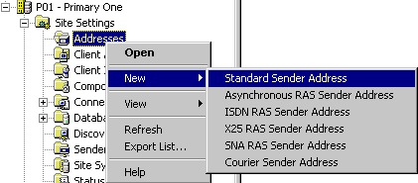

- Enter the Destination site code and Site server name.

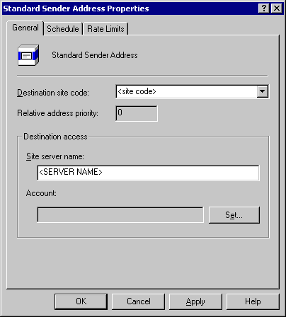 | 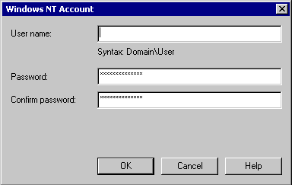

- Set the account name for the sender address by clicking the Set… button. Enter the correct Username and Password for the sender account created in Section 1. Click OK.
- Accept the defaults for Schedule and Rate Limits, and click OK.

Go to Section 3.2 for secondary site installation instructions.

primary Site installation

The primary site installation is a three (3) part process:

- Installation of SQL Server 2000
- Installation of SMS 2.0 SP2
- Upgrade to SMS 2.0 SP3

Installation of SQL Server 2000

- Insert SQL Server 2000 CD and wait for the autorun feature to begin.
- Select SQL Server 2000 Components.

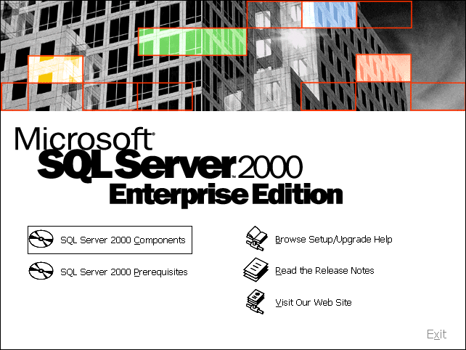

- Select Install Database Server.

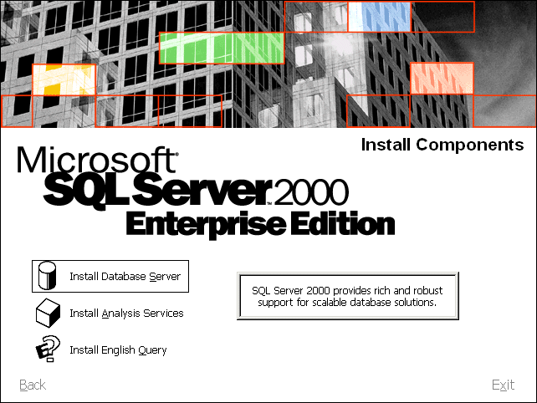
- Click on Next.

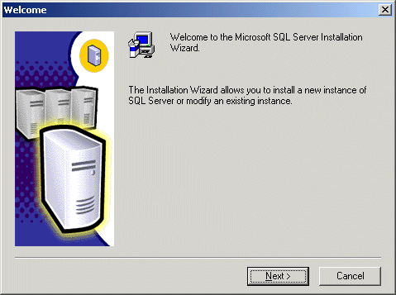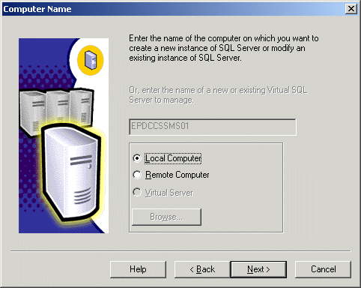

- Ensure that the Local Computer option is selected. Click on Next.
- Select the Create a new instance of SQL Server or install Client Tools option and click Next.

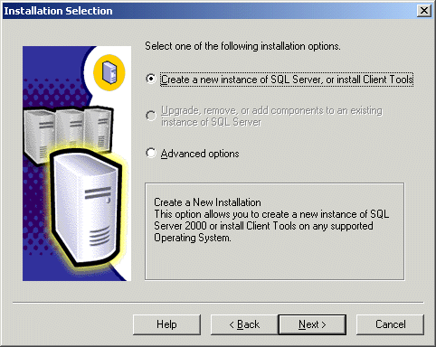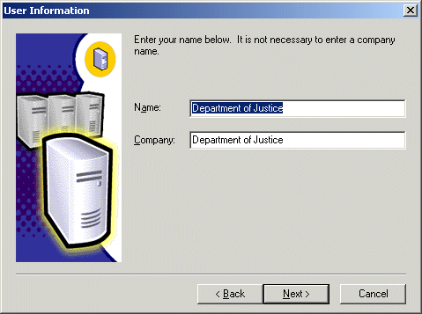

- Enter Department of Justice into both the Name and Company fields. Click Next.
- Accept the license agreement by clicking Yes.

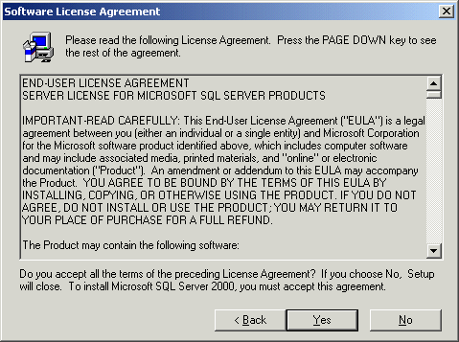
- Select the Server and Client Tools option. Click Next.

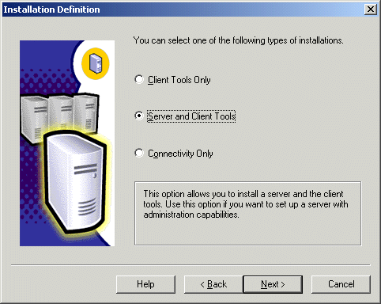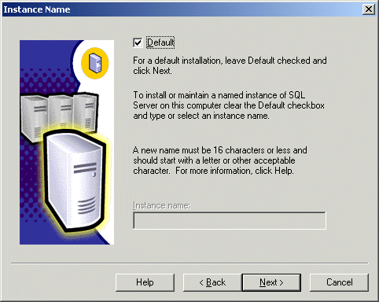

- Ensure that the Default instance checkbox is ticked. Click Next.
- Choose the Custom option. Enter the destination folder for the SQL Program Files and Data Files. If possible, place the data files on a different partition/drive to the program files. Click Next.

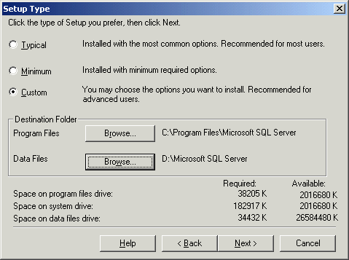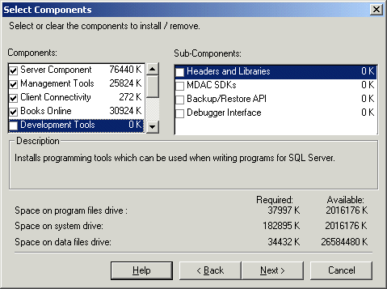

- Uncheck Development Tools and click Next.
- Ensure that the Use the same account for each service. Auto start SQL Server Service option is selected. Click on the Use a Domain User Account radio button and fill in the account details. Click Next.

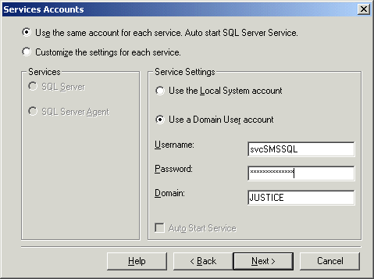
- Select Mixed Mode (Windows Authentication and SQL Server Authentication). Enter the new password for the sa account. Click Next.

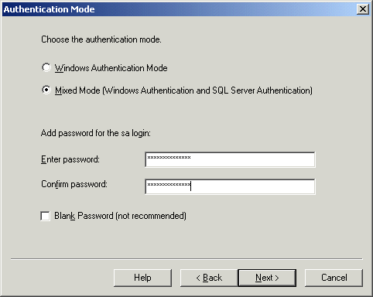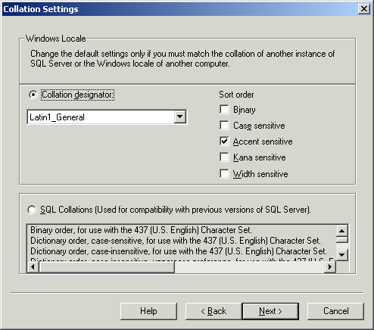

- Keep the default Collation Settings and click Next.
- Keep the default Network Libraries settings and click Next.

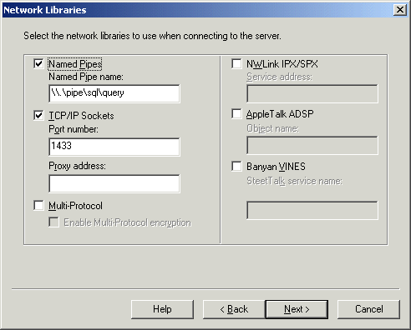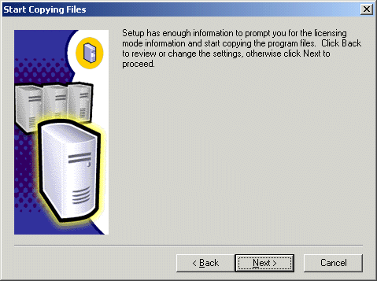

Click Next.
- Select the Processor License for option and enter the number of processors. Click Continue.

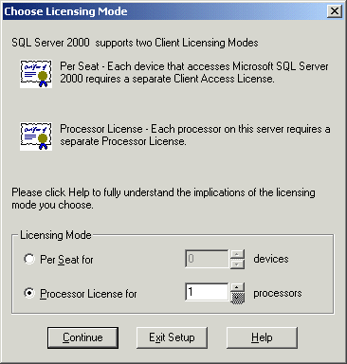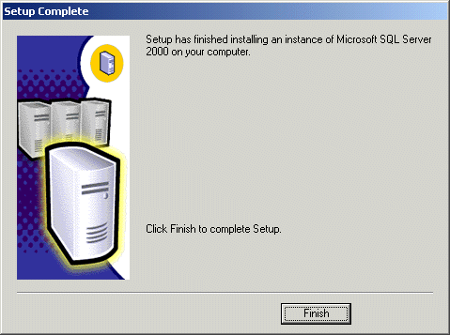

- Click Finish. SQL Server 2000 will be installed on the prospective SMS primary site server.
- If required, SQL Server 2000 SP1 can be installed.

Installation of SMS 2.0 SP2

- Insert SMS 2.0 SP2 CD and wait for the autorun feature to begin.

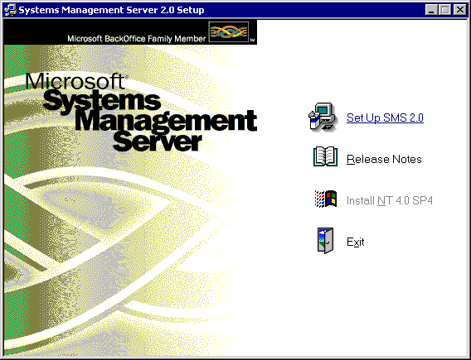

- Click on Set Up SMS 2.0.
- At the Welcome screen, click Next.

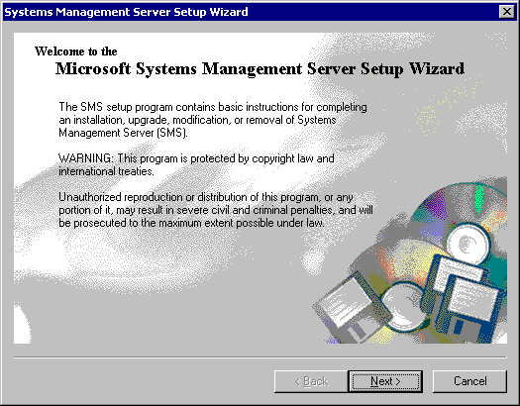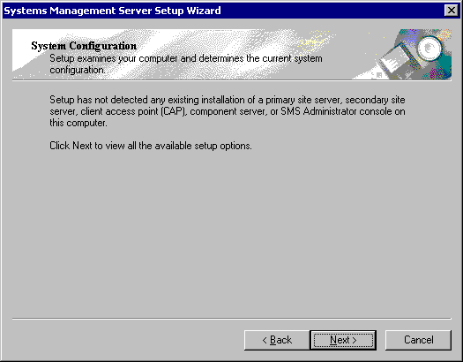

- At the System Configuration screen, click Next.
- Select the Install an SMS primary site option. Click Next.

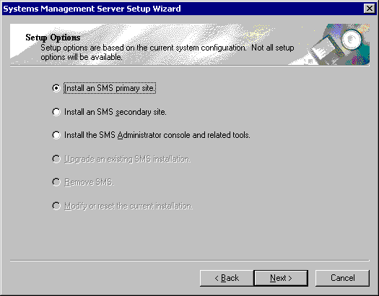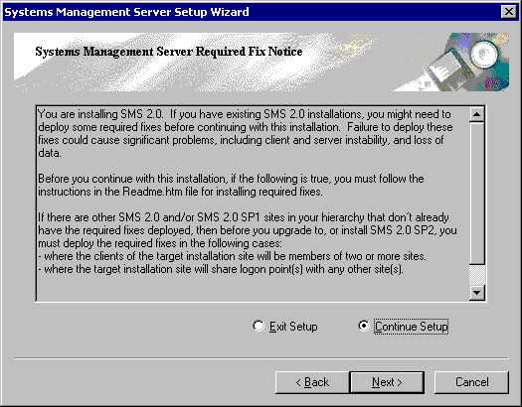

- Choose the Continue Setup option and click Next.
- Accept the license agreement by selecting the I Agree option. Click Next.

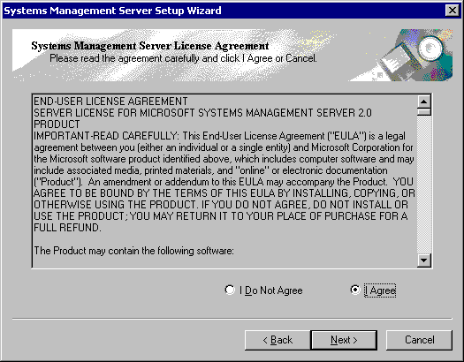
- Enter Department of Justice into both the Name and Organisation fields.

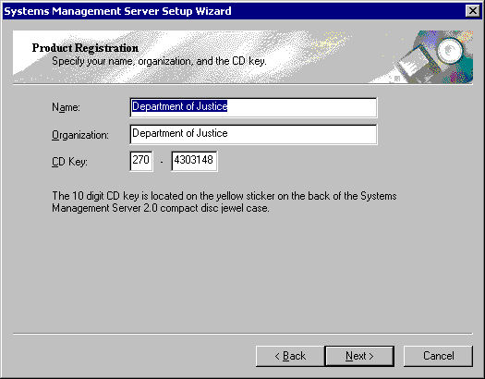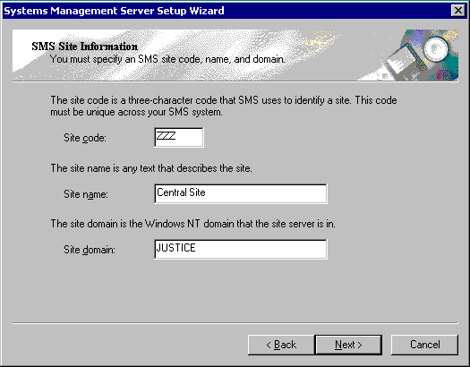

- At the SMS Site Information screen, enter the three character Site code, the Site name and Site domain. Site codes can be found in Appendix B.
- At the SMS Service Account Information screen, enter the Account name and Password of the account that is to be used to run the SMS services. This account can be created beforehand or the SMS setup program can create it as part of the installation process. The account must be a member of the Domain Admins group and have Log On As A Service rights. Click Next.

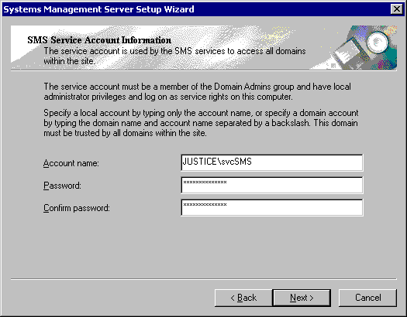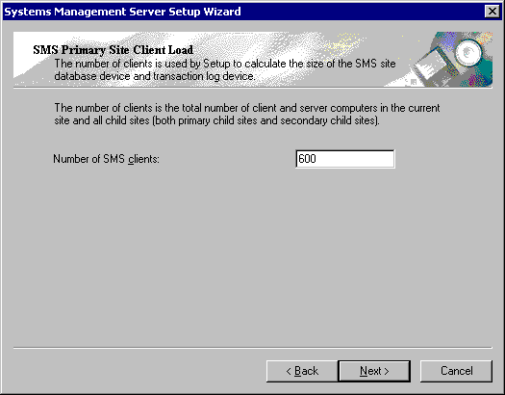

- At the SMS Primary Site Client Load screen, enter the estimated total number of clients that the primary site will service. This figure will be used by the SMS setup program to determine the initial size of the SMS database and transaction devices. For the central site, the figure will be 3000 and for primary sites, the figure will be 600.
- At the SMS Server Platform screen, ensure that the ALPHA option is left unchecked. Click Next.

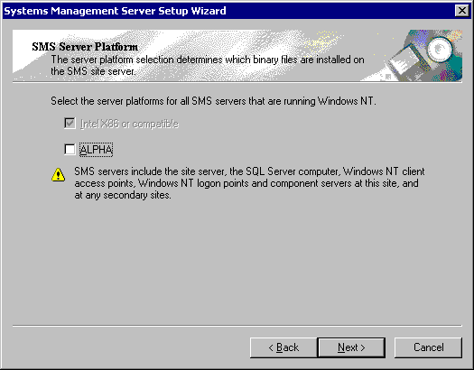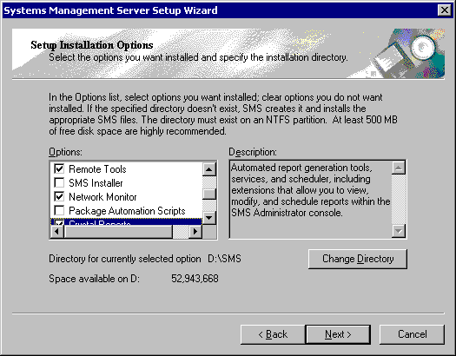

- Select Remote Tools, Network Monitor and Crystal Reports options. Click Next.
- Select Yes when presented with the Crystal Reports dialogue.

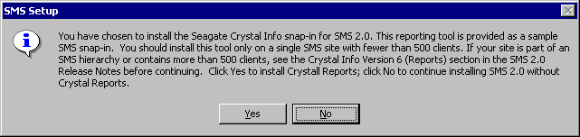

- Select the SQL Server 2000 or above option and ensure Integrated Security is not selected. Click Next.

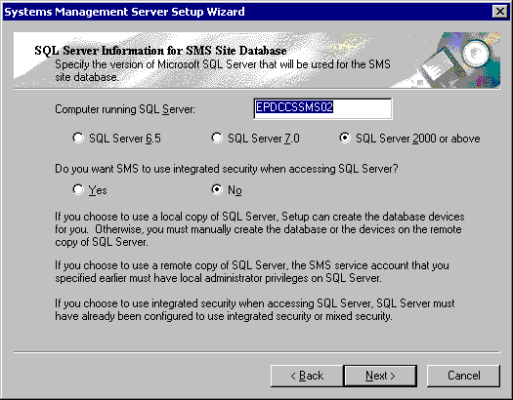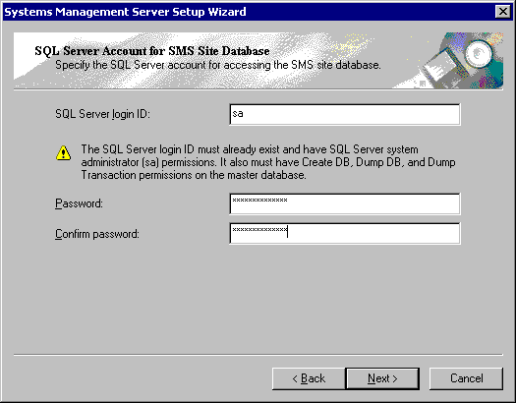

- At the SQL Server Account for SMS Site Database screen, enter the password for the sa account (as per the separate password document). Click Next.
- Allow the SMS setup program to create the SMS database by selecting Yes at the SQL Server Devices for the SMS Database screen. Click Next.

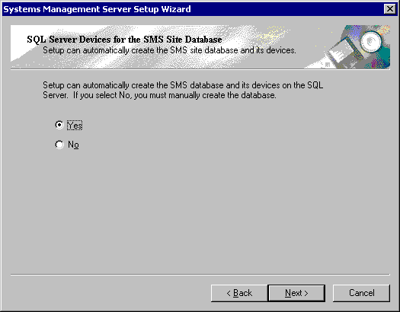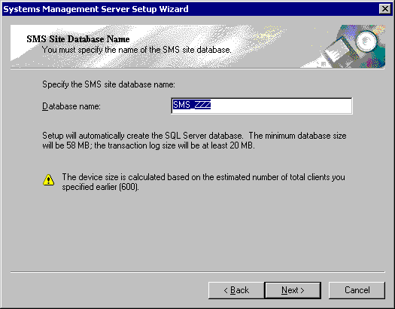

- Accept the default name given to the SMS database. Click Next.
- At the SQL Server Device Directory Path for SMS Site Database screen, enter the appropriate folder path to the SMS database devices. The path can be entered directly or via the Browse… button. Click Next.

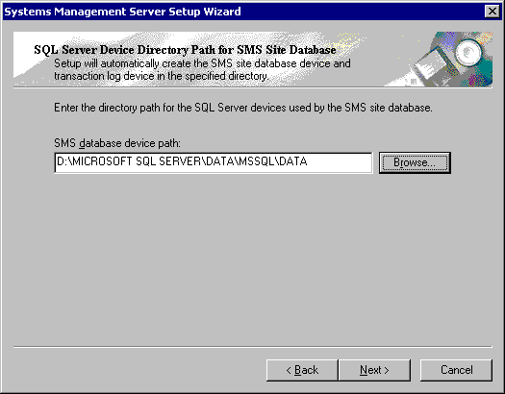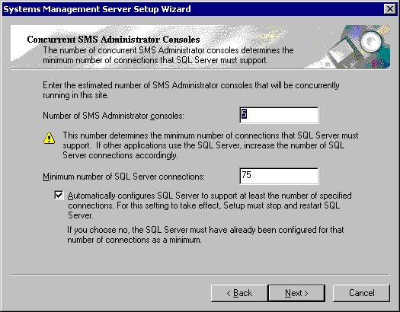

- At the Concurrent SMS Administrator Consoles screen, accept the default values (Number of SMS Administrator consoles: 5, Minimum number of SQL Server connections: 75). Click Next.
- A summary of the parameters entered will be displayed on the final setup screen. Check that everything is correct and click on Finish to initiate the install procedure.

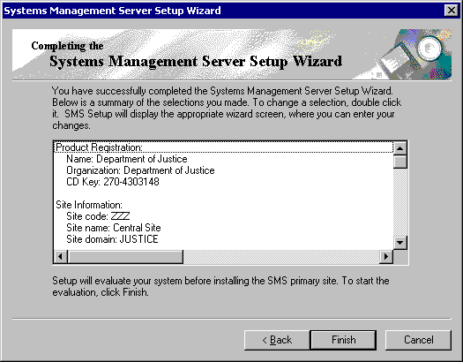

- Before installation can begin, the program waits for the user account database to be synchronised. This can take several minutes to complete, and is dependent upon the replication period used in the Windows 2000 environment.

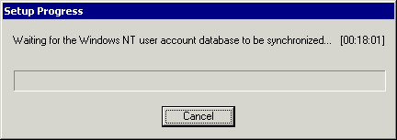

Installation of SMS 2.0 SP3

- Insert SMS 2.0 SP3 CD and wait for the autorun feature to begin.
- Follow onscreen instructions to upgrade primary site to SMS 2.0 SP3.

Post Installation Tasks

- Using the SMS Administrators console, remove site boundary for the newly created primary site.
- Give the SMS Site Senders group Full Control access to the D:\SMS\inboxes\despooler.box\receive folder.
- Enable logging for Data Discovery Manager, Client Configuration Manager, Network Discovery, LAN Sender, Replication Manager and Scheduler.

Secondary site installation

The source files for the installation of a secondary site should have been copied to the server during the build process. They can be found under the C:\Admin\sms_secondary_source folder.

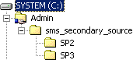

If the files have been copied follow the instructions outlined in Section 3.2.1. If not, follow the instructions in Section 3.2.2.

Installation via Terminal Services Client

- Connect to the prospective secondary site server using Terminal Services Client and log on as a domain administrator.
- Click on Start -> Run. Type in the following path and click OK.

C:\Admin\sms_secondary_source\SP2\SMSSETUP\Bin\I386\setup.exe

- Click Next.

- Click Next.
- Select the Install an SMS secondary site option and click Next.

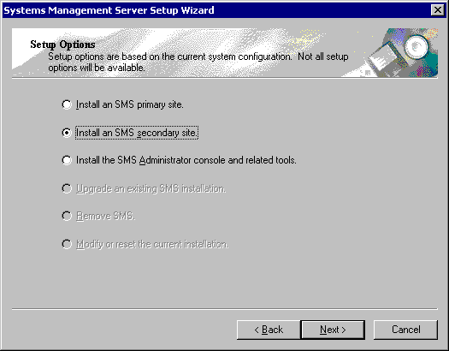

- Choose Continue Setup and click Next.
- Accept the licence agreement by selecting I Agree. Click Next.

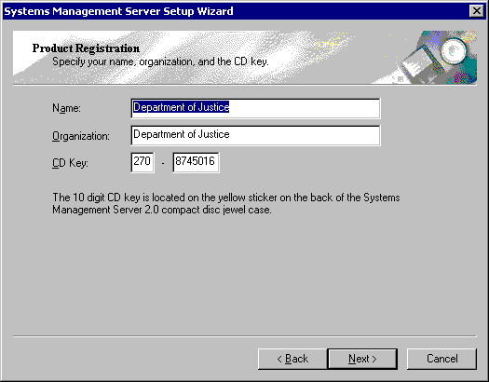

- Enter Department of Justice into both the Name and Organisation fields. Click Next.
- At the SMS Site Information screen, enter the three character Site code, Site name and Site domain. Click Next. Site codes can be found in Appendix B.

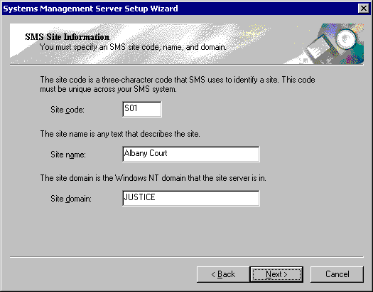
- At the SMS Service Account Information screen, enter the Account name and Password of the account that is to be used to run the SMS services. This account was created during the primary site installation. The account is a member of the Domain Admins group and has Log On As A Service rights. Click Next.

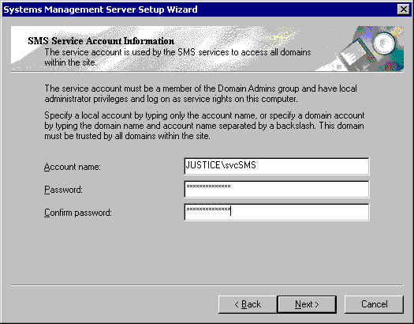

- Ensure the ALPHA option is unchecked. Click Next.
- Select Remote Tools from the option list and click Next.

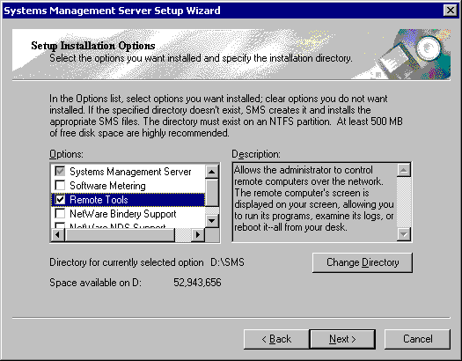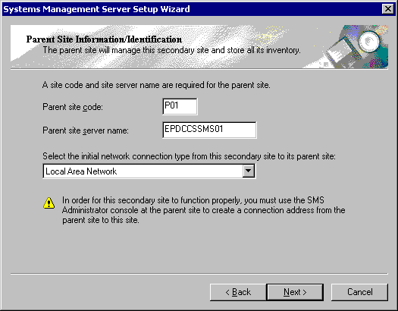

- At the Parent Site Information Identification screen, enter the Parent site code and Parent site server. Leave the default network connection type of Local Area Network. Click Next.
- At the Connection Account Information screen, enter the username and password of the account that will be used to communicate with the parent site. Click Next.

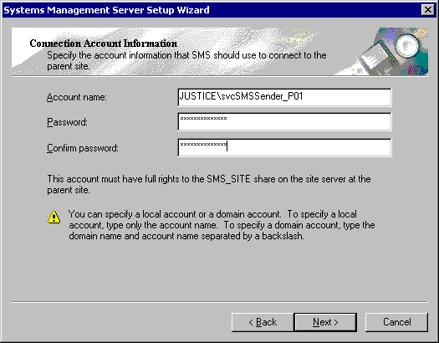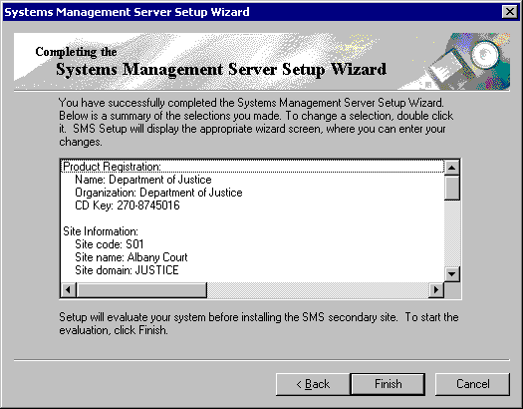

- A summary of the parameters entered will be displayed on the final setup screen. Check that everything is correct and click on Finish to initiate the install procedure.
- Before installation can begin, the program waits for the user account database to be synchronised. This can take several minutes to complete, and is dependent upon the replication period used in the Windows 2000 environment.

Installation of SMS 2.0 SP3

- Connect to the prospective secondary site server using Terminal Services Client and log on as a domain administrator.
- Click on Start -> Run. Type in the following path and click OK.

C:\Admin\sms_secondary_source\SP3\SMSSETUP\Bin\I386\setup.exe

- Follow onscreen instructions to upgrade primary site to SMS 2.0 SP3.

Installation via SMS Administrators Console

- Determine which primary site will act as the parent site to the new secondary site installation.
- Right-click on the chosen primary site and select New -> Secondary Site.

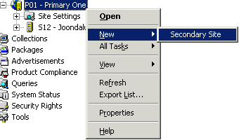

- Click Next.

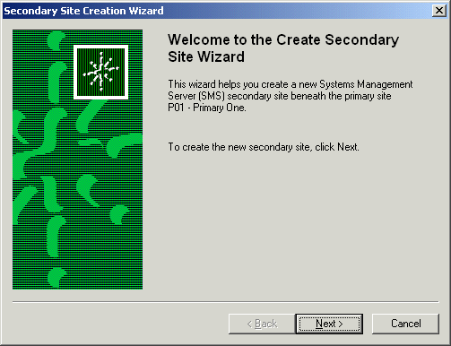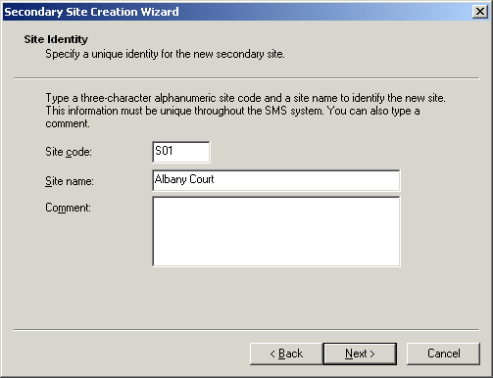

- At the Site Identity screen, enter the Site code and Site name. If required, the Comment field can be filled in. Click Next.
- At the Site Server screen, enter details for Site server domain, Site server and Installation directory. Accept the default Processor platform setting of Intel X86 and compatible. Click Next.

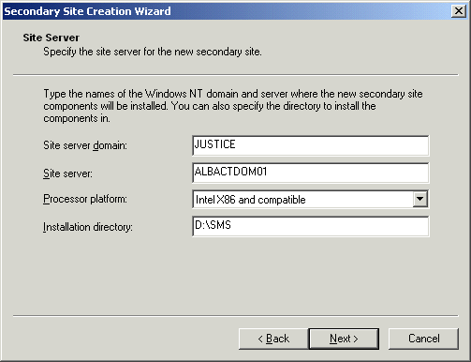

- Ensure that the Transfer installation source files from parent site server option is selected. This will allow the installation package to be transferred to the prospective secondary site server in compressed form. Click Next.

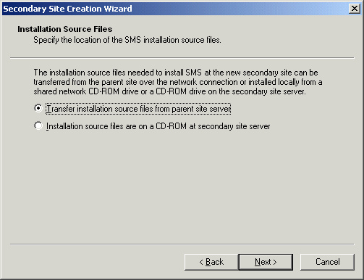

- At the SMS Service Account Information screen, enter the Account name and Password of the account that is to be used to run the SMS services. This account was created during the primary site installation. The account is a member of the Domain Admins group and has Log On As A Service rights. Click Next.

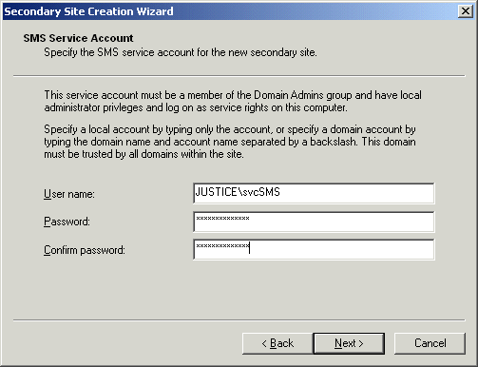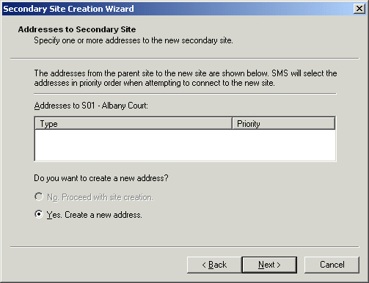

- Accept the default Yes. Create a new address option and click Next.
- At the New Address to Secondary Site screen, accept the default Address type of Standard Sender Address. Enter the name of the Destination site server and set the connection account parameters by clicking on the Set… button.

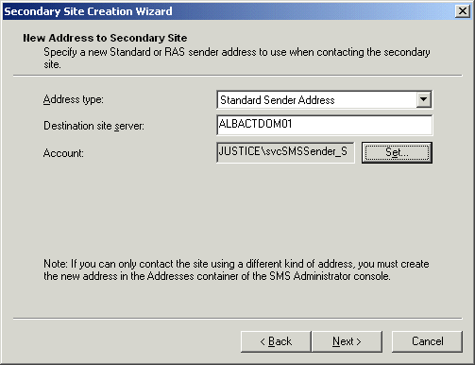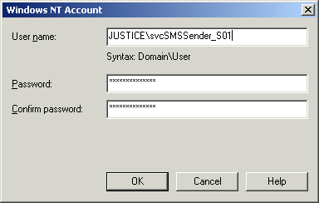

- Enter the username and password of the desired connection account. The parent site will use this account to communicate to the new secondary site server. Once the details have been set, click on OK. Click on Next.
- At the New Address to Parent Site screen, accept the default Address type of Standard Sender Address. Enter the name of the Destination site server and set the connection account parameters by clicking on the Set… button.

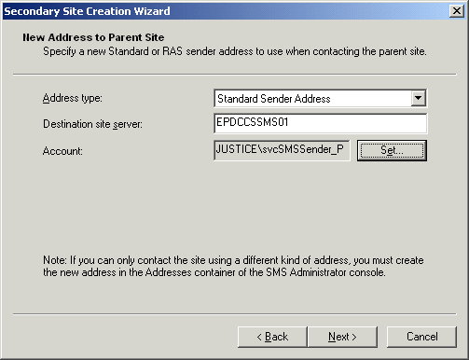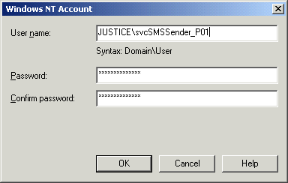

- Enter the username and password of the desired connection account. The new secondary site will use this account to communicate to the parent site server. Once the details have been set, click on OK. Click on Next.
- A summary of the parameters entered will be displayed on the final setup screen. Check that everything is correct and click on Finish to initiate the install procedure.

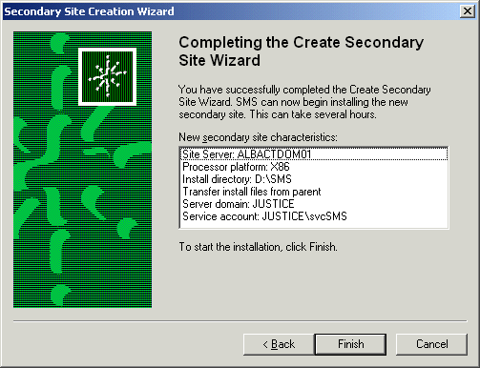

- Before installation can begin, the program waits for the user account database to be synchronised. This can take several minutes to complete, and is dependent upon the replication period used in the Windows 2000 environment.

Post Installation Tasks

- Give the SMS Site Senders group Full Control access to the D:\SMS\inboxes\despooler.box\receive folder on the newly created secondary site.
- Enable logging for Discovery Data Manager, Client Configuration Manager, Network Discovery, LAN Sender, Replication Manager, NT Logon Server Manager and Scheduler.
- Using the SMS Administrators Console, create a query and corresponding collection for the new secondary site using subnet and/or installed site as the selection criteria.
- Set the Remote Installation Account in the site properties.
- Update distribution points with the CSC SMS Test Package 1.0 English package.
- Update distribution points with the CSC Laptop Travel Mode 1.0 English package.

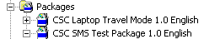

- Create advertisement to run the CSC SMS Test Package 1.0 English package on all desktops. This is to test the software distribution function. The advertisement should be Mandatory and set to expire after a couple of hours.

- Create advertisement to install the CSC Laptop Travel Mode 1.0 English package on all laptops. This advertisement should be Mandatory and set to Never expire.

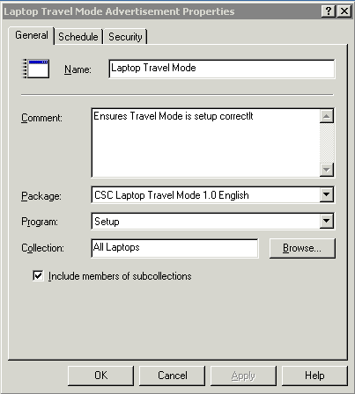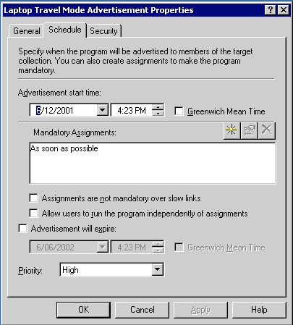

- The advertisements should look similar to the following:

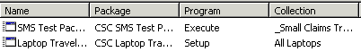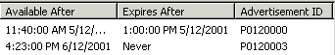

site configuration

After installing the SMS site, a number of components need to be configured. These components can be broken into the following categories:

- Client Agents
- Client Installation Methods
- Discovery Methods
- Component Configuration
- Connection Accounts

The following sections describe the configuration of each component. All configuration tasks are accomplished via the SMS Administrators console and additional information is supplied in various appendices.

Client Agents

Hardware Inventory Client Agent

- The purpose of this agent is to collect hardware information from target computers and forward it to the parent site server. The data is collated and stored in the SMS database to be used in queries and reports.
- Enable the hardware inventory agent by ticking the Enable hardware inventory on clients checkbox.

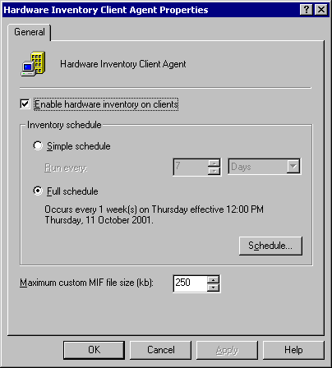

- Set a full weekly schedule by clicking on the Schedule… button and filling in the parameters. Schedules for all sites can be found in Appendix C.
- On completion, click OK. After a few minutes, the site control file will be updated with the new configuration.

Software Inventory Client Agent

- The purpose of this agent is to collect software information from target computers and forward it to the parent site server. The data is collated and stored in the SMS database to be used in queries and reports.
- Enable the software inventory agent by ticking the Enable software inventory on clients checkbox.
- Set a full weekly schedule by clicking on the Schedule… button and filling in the parameters. Schedules for all sites can be found in Appendix C.

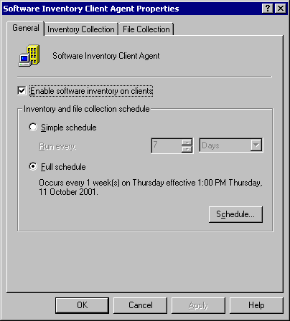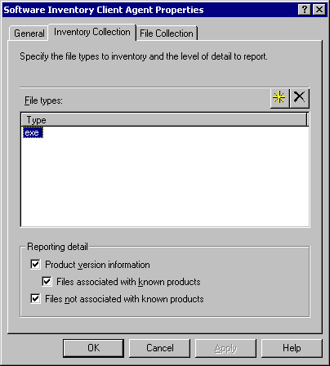

- On the Reporting tab, ensure that the only file type is exe and that all Reporting detail options are selected.
- On the File Collection tab, ensure that the Files to be collected box is left blank. Accept the default Maximum data collected per client (MB) setting of 1.

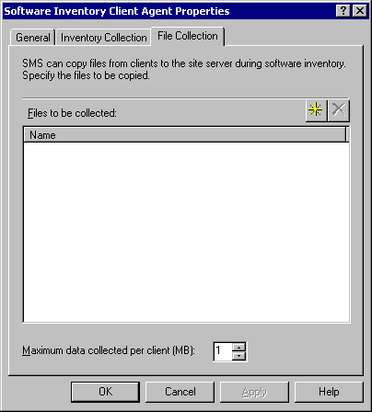

- On completion, click OK. After a few minutes, the site control file will be updated with the new configuration.

Remote Tools Client Agent

- The Remote Tools agent is a suite of utilities that gives helpdesk staff the ability to support workstations and servers across the network. Functions available are remote control, remote reboot, remote file transfer and remote execute.
- Enable the remote tools agent by ticking the Enable remote tools on clients checkbox. Ensure that the Clients cannot change Policy or Notification settings option is ticked.

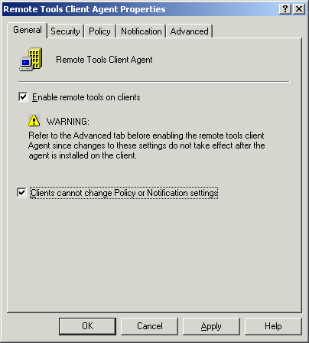

- On the Security tab, remove all members of the Permitted viewers list, except for Administrators.

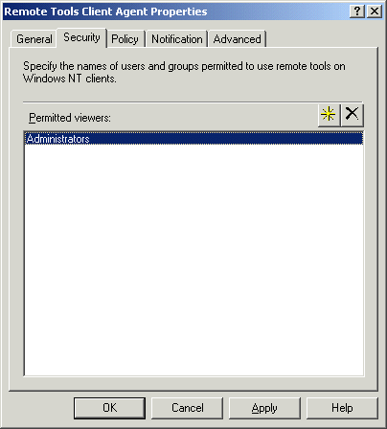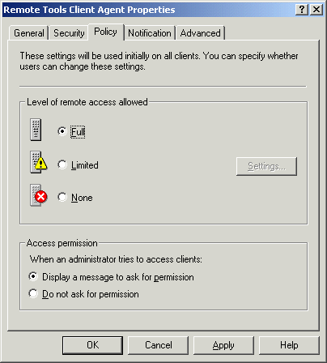

- On the Policy tab, set the Level of remote access allowed parameter to Full and the Access permission parameter to Display a message to ask for permission.
- Select the Notification tab. Tick the Display a visual indicator checkbox and choose the Show status icon on taskbar option. Tick the Play a sound option and select the When session begins and ends option.

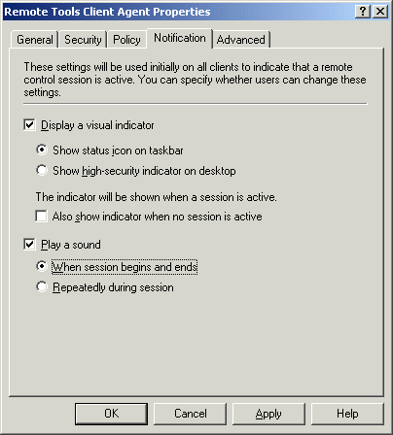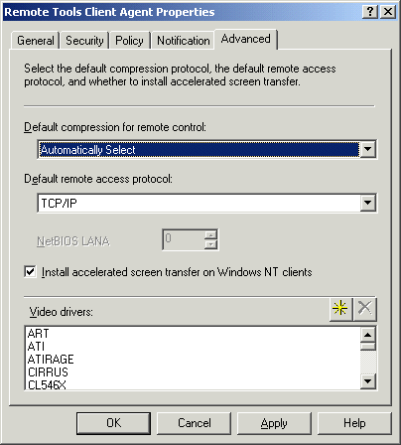

- Accept the defaults on the Advanced tab.
- On completion, click OK. After a few minutes, the site control file will be updated with the new configuration.

Advertised Programs Client Agent

- The purpose of the advertised programs agent is to look for and accept software installation offers from the SMS client’s site server. Once an offer has been accepted, the agent will carry out the deployment as per the instructions in the SMS software package.
- Enable the advertised programs client agent by ticking the Enable software distribution to clients checkbox. Ensure that the Clients cannot change agent settings option is ticked.

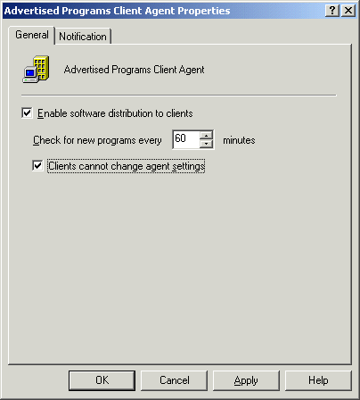
- Click on the Notification tab. Choose both options under the When new advertised programs are available section. Under the When a scheduled program is about to run section, tick the Provide a countdown checkbox. Set the Countdown length to 5 minutes and leave the Play countdown sounds checkbox unticked.

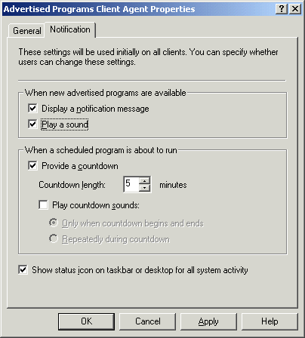

- On completion, click OK. After a few minutes, the site control file will be updated with the new configuration.

Event to Trap Translator Client Agent

- The Event to Trap Translator agent will not be used in this SMS installation.

Client Installation Methods

Windows Networking Logon Client Installation

- This installation method allows the SMS client to be installed onto a computer via a logon script.
- Enable the logon installation method by ticking the Enable Windows Networking Logon Client Installation checkbox. Add the JUSTICE domain to the Logon points list. As logon discovery is not being used in this SMS installation, the Keep logon point lists for discovery and installation synchronised option can be left unticked. NOTE: Logon Installation applies to secondary sites only.

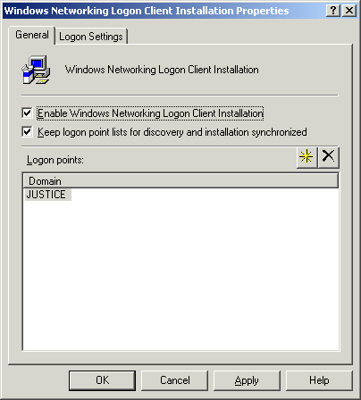

- On the Logon Settings tab, ensure that the Modify user logon scripts checkbox is not selected. Accept the default 1 day for the Logon point update schedule.

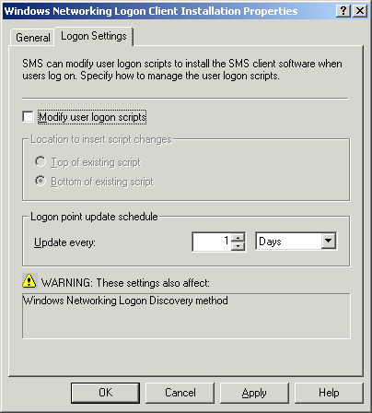

- On completion, click OK. After a few minutes, the site control file will be updated with the new configuration.

Windows NT Remote Client Installation

- The remote client installation method allows the SMS client to be installed on a computer via an implemented discovery method e.g. network discovery.
- Enable the logon installation method by ticking the Enable Windows NT Remote Client Installation checkbox. Under the System types section, choose the Windows NT Server and Domain controllers options.

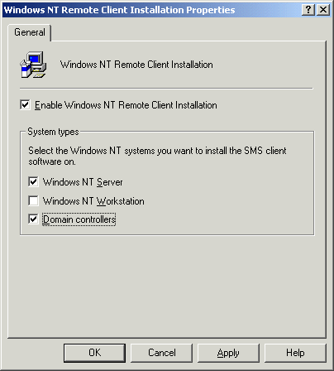

- On completion, click OK. After a few minutes, the site control file will be updated with the new configuration.

Discovery Methods

Windows Networking Logon Discovery

- The Windows Networking Logon Discovery method will not be used in this SMS installation.

Windows NT User Account Discovery

- This discovery method is used to accumulate a listing of all user accounts in the specified domain.
- Enable the user account discovery method by ticking the Enable Windows NT User Account Discovery checkbox. Add the JUSTICE domain to the Logon points list.

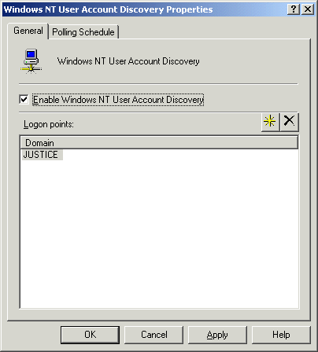

- On the Polling Schedule tab, enter a schedule by clicking on the Schedule… button. Schedules are defined in Appendix D.

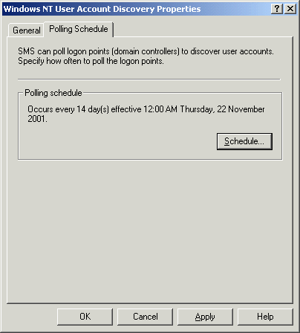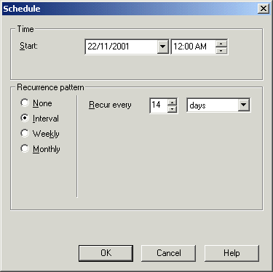

- On completion, click OK. After a few minutes, the site control file will be updated with the new configuration.

Windows NT User Group Discovery

- This discovery method is used to accumulate a listing of all user groups in the specified domain.
- Enable the user group discovery method by ticking the Enable Windows NT User Group Discovery checkbox. Add the JUSTICE domain to the Logon points list.

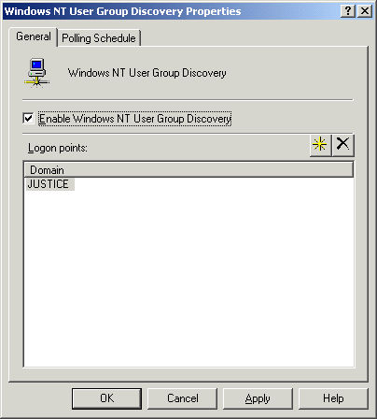

- On the Polling Schedule tab, enter a schedule by clicking on the Schedule… button. Schedules are defined in Appendix D.

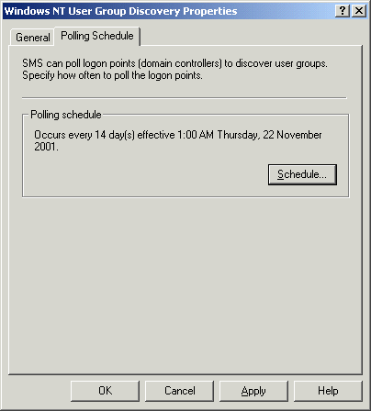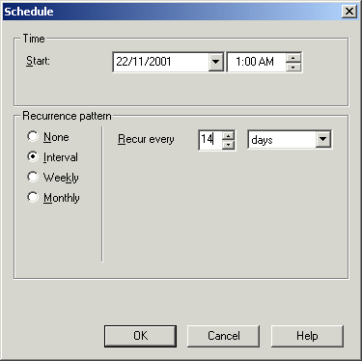

- On completion, click OK. After a few minutes, the site control file will be updated with the new configuration.

Heartbeat Discovery

- The heartbeat discovery method is used by the SMS site server to determine whether the assigned clients are still active.
- Enable the heartbeat discovery method by ticking the Enable Heartbeat Discovery checkbox. Accept the default value of 1 week for the Heartbeat schedule

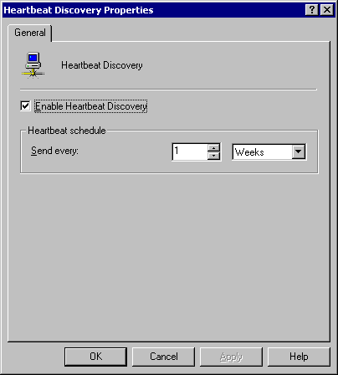

Network Discovery

- The network discovery method is used to locate network devices by performing queries on subnets, domains, SNMP hosts and DHCP scopes. The information is stored in the SMS database and can form the basis of the Remote Client Installation method.
- Enable the network discovery method by ticking the Enable network discovery checkbox. Select the Topology, client and client operating system option.

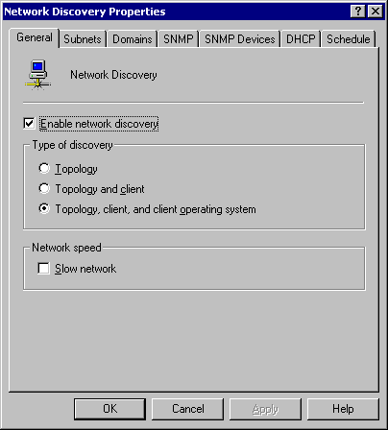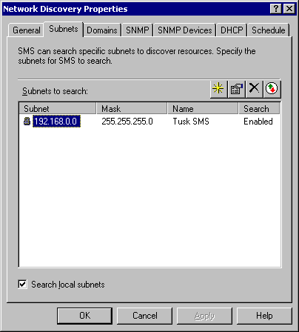

- On the Subnets tab, add the subnets to be searched (site boundaries). If the only subnet is the local one, leave the Subnets to search box empty and select the Search local subnets option.
- On the Domain tab, add the domains to be searched. If the only domain is the local one, leave the Domains box empty and select the Search local domain option.

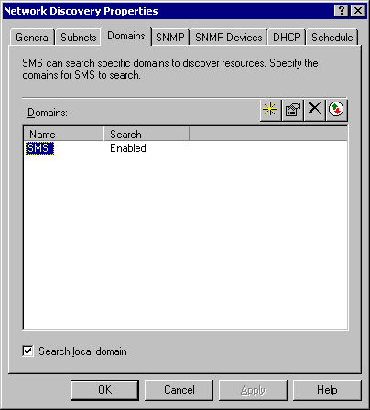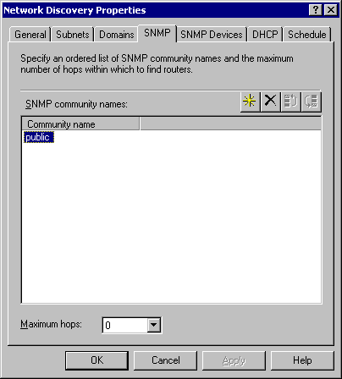

- On the SNMP tab, accept the default SNMP community name of public.
- On the SNMP Devices tab, ensure the SNMP devices box is empty.

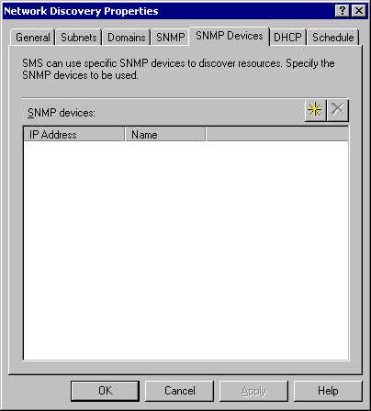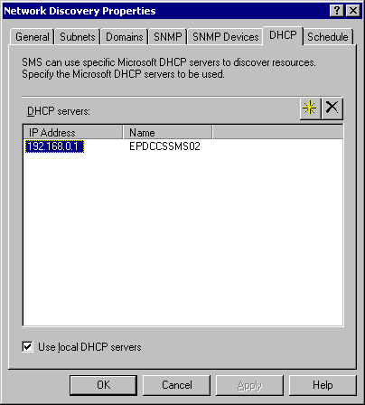

- On the DHCP tab, add the names of the DHCP servers to be searched. If the only server is the local one, leave the DHCP servers box empty and select the Use local DHCP servers option.
- Click on the Schedule tab. Enter a weekly schedule as defined in Appendix D. Set the discovery Duration to 1 hour.

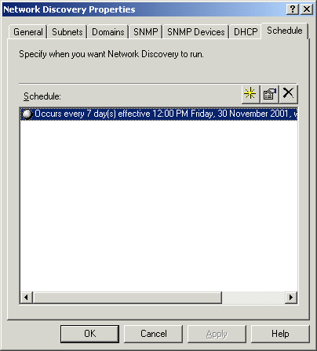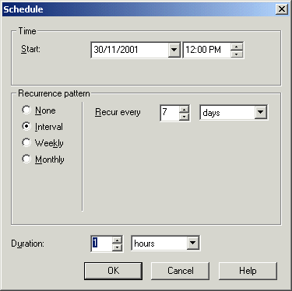

- On completion, click OK. After a few minutes, the site control file will be updated with the new configuration.

Component configuration

- For all secondary sites, the software distribution component requires additional configuration. In the SMS Administrators console, click on Component Configuration. Double-click on the Software Distribution option.

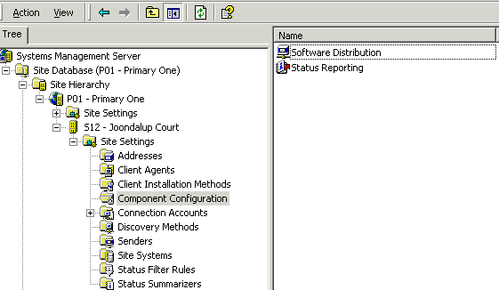
- Under the Location of stored packages section, enter a reference to the drive where SMS packages will be located. The format will be <drive letter>:\. For Courts servers, this will be either D or E drive.

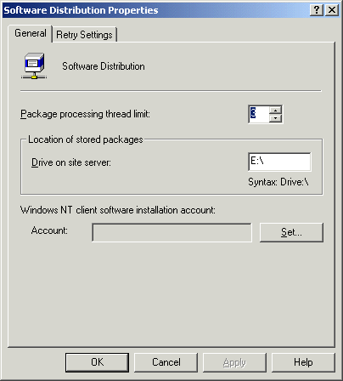

- Click OK.

Connection accounts

To increase redundancy at all sites, additional Client Connection accounts have been created. The extra accounts prevent a site becoming orphaned if the active account becomes locked out. All account details are in Appendix A.

- In the SMS Administrators console, expand the Connection Accounts section. Right-click on Client and select New -> Windows NT.

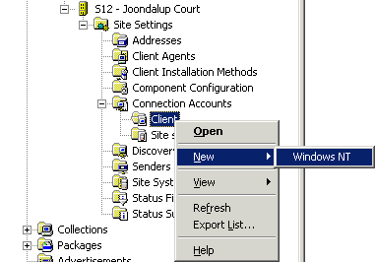
- Enter the connection account details by clicking on the Set… button.

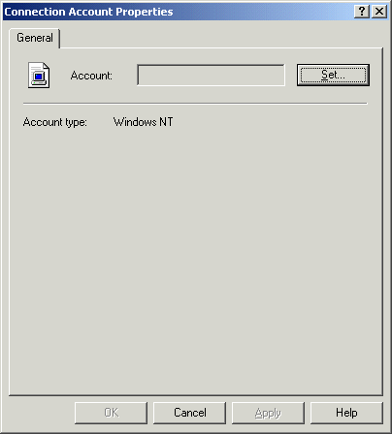

- Fill in the User name and Password fields. Click OK.

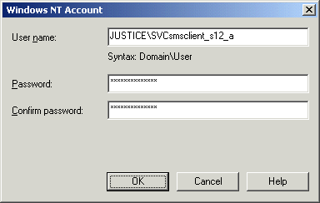

- Click OK.

Address scheduling

To reduce the impact that SMS has on WAN links, the site addresses can be configured to control the flow of information between site servers. Flow control can be based on priority level and bandwidth usage.

- The sender address settings are under the Address section in the SMS Administrators console.
- Right-click on the address and choose Properties.

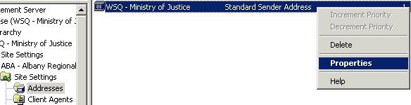

- On the Schedule tab, assign an Availability setting as per the table below:

Time Period | Availability
12am – 2am | Allow medium and high priority
2am – 8am | Allow all priorities
8am – 5pm | Allow medium and high priority
5pm – 10pm | Allow all priorities
10pm – 12am | Allow medium and high priority

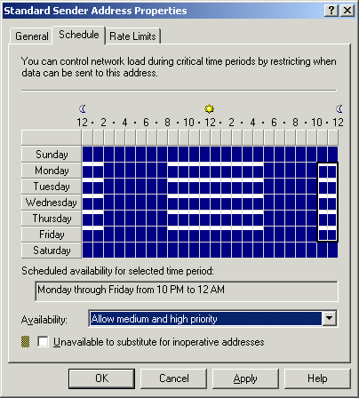
- On the Rate Limits tab, select the Limited to specified maximum transfer rates by hour radio button. Assign Limit (% of connection bandwidth) settings as per the table below:

Time Period | Bandwidth (%)
12am – 2am | 50
2am – 8am | 100
8am – 5pm | 50
5pm – 10pm | 100
10pm – 12am | 50

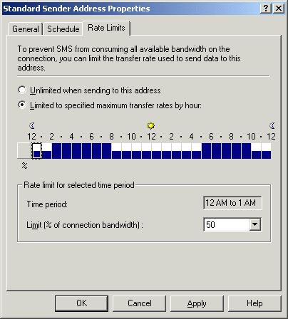

- These settings serve only as a guideline. Sites may have individual needs that require further customisation of the address schedule and rate parameters.

Status message summarisation

To conserve network bandwidth, the status message summarisers can be configured so that status messages are replicated during periods of low network utilisation.

- The status message summariser settings are found under the Status Summarizers section in the SMS Administrators console.

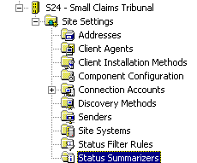
- Double-click on Component Status Summarizer. Set the Replication priority to High and the Threshold period to Since 12:00:00 AM. Keep the default threshold values. Click OK.

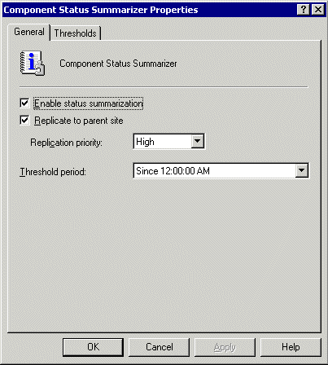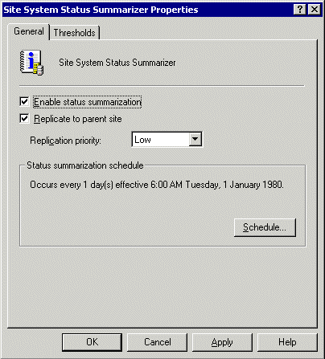

- Double-click on Site System Status Summarizer. Set the Replication priority to Low and configure a schedule of once per day. The time of the replication will vary from site to site. Keep the default threshold values. Click OK.

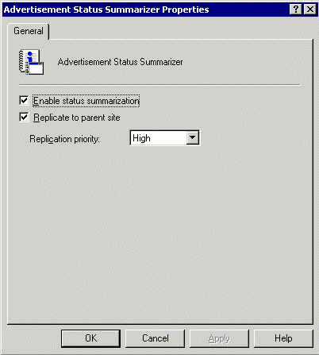

- Double-click on Advertisement Status Summarizer. Set the Replication priority to High. Keep the default threshold values. Click OK.

Appendix A – sms accounts

Site Code | Sender Account | Client Account 1 | Client Account 2 | Client Account 3
ZZZ | svcSMSSender_ZZZ | N/A | N/A | N/A
P01 | svcSMSSender_P01 | N/A | N/A | N/A
P02 | svcSMSSender_P02 | N/A | N/A | N/A
S01 | svcSMSSender_S01 | SMSClient_S01 | SMSClient_S01_A | SMSClient_S01_B
S02 | svcSMSSender_S02 | SMSClient_S02 | SMSClient_S02_A | SMSClient_S02_B
S03 | svcSMSSender_S03 | SMSClient_S03 | SMSClient_S03_A | SMSClient_S03_B
S04 | svcSMSSender_S04 | SMSClient_S04 | SMSClient_S04_A | SMSClient_S04_B
S05 | svcSMSSender_S05 | SMSClient_S05 | SMSClient_S05_A | SMSClient_S05_B
S06 | svcSMSSender_S06 | SMSClient_S06 | SMSClient_S06_A | SMSClient_S06_B
S07 | svcSMSSender_S07 | SMSClient_S07 | SMSClient_S07_A | SMSClient_S07_B
S08 | svcSMSSender_S08 | SMSClient_S08 | SMSClient_S08_A | SMSClient_S08_B
S09 | svcSMSSender_S09 | SMSClient_S09 | SMSClient_S09_A | SMSClient_S09_B
S0A | svcSMSSender_S0A | SMSClient_S0A | SMSClient_S0A_A | SMSClient_S0A_B
S0B | svcSMSSender_S0B | SMSClient_S0B | SMSClient_S0B_A | SMSClient_S0B_B
S0C | svcSMSSender_S0C | SMSClient_S0C | SMSClient_S0C_A | SMSClient_S0C_B
S0D | svcSMSSender_S0D | SMSClient_S0D | SMSClient_S0D_A | SMSClient_S0D_B
S0E | svcSMSSender_S0E | SMSClient_S0E | SMSClient_S0E_A | SMSClient_S0E_B
S0F | svcSMSSender_S0F | SMSClient_S0F | SMSClient_S0F_A | SMSClient_S0F_B
S10 | svcSMSSender_S10 | SMSClient_S10 | SMSClient_S10_A | SMSClient_S10_B
S11 | svcSMSSender_S11 | SMSClient_S11 | SMSClient_S11_A | SMSClient_S11_B
S12 | svcSMSSender_S12 | SMSClient_S12 | SMSClient_S12_A | SMSClient_S12_B
S13 | svcSMSSender_S13 | SMSClient_S13 | SMSClient_S13_A | SMSClient_S13_B
S14 | svcSMSSender_S14 | SMSClient_S14 | SMSClient_S14_A | SMSClient_S14_B
S15 | svcSMSSender_S15 | SMSClient_S15 | SMSClient_S15_A | SMSClient_S15_B
S16 | svcSMSSender_S16 | SMSClient_S16 | SMSClient_S16_A | SMSClient_S16_B
S17 | svcSMSSender_S17 | SMSClient_S17 | SMSClient_S17_A | SMSClient_S17_B
S18 | svcSMSSender_S18 | SMSClient_S18 | SMSClient_S18_A | SMSClient_S18_B
S19 | svcSMSSender_S19 | SMSClient_S19 | SMSClient_S19_A | SMSClient_S19_B
S1A | svcSMSSender_S1A | SMSClient_S1A | SMSClient_S1A_A | SMSClient_S1A_B
S1B | svcSMSSender_S1B | SMSClient_S1B | SMSClient_S1B_A | SMSClient_S1B_B
S1C | svcSMSSender_S1C | SMSClient_S1C | SMSClient_S1C_A | SMSClient_S1C_B
S1D | svcSMSSender_S1D | SMSClient_S1D | SMSClient_S1D_A | SMSClient_S1D_B
S1E | svcSMSSender_S1E | SMSClient_S1E | SMSClient_S1E_A | SMSClient_S1E_B
S1F | svcSMSSender_S1F | SMSClient_S1F | SMSClient_S1F_A | SMSClient_S1F_B
S20 | svcSMSSender_S20 | SMSClient_S20 | SMSClient_S20_A | SMSClient_S20_B
S21 | svcSMSSender_S21 | SMSClient_S21 | SMSClient_S21_A | SMSClient_S21_B
S22 | svcSMSSender_S22 | SMSClient_S22 | SMSClient_S22_A | SMSClient_S22_B
S23 | svcSMSSender_S23 | SMSClient_S23 | SMSClient_S23_A | SMSClient_S23_B
S24 | svcSMSSender_S24 | SMSClient_S24 | SMSClient_S24_A | SMSClient_S24_B
S25 | svcSMSSender_S25 | SMSClient_S25 | SMSClient_S25_A | SMSClient_S25_B
S26 | svcSMSSender_S26 | SMSClient_S26 | SMSClient_S26_A | SMSClient_S26_B

appendix b – sms site codes

Site Name | Site Code
Central Site | ZZZ
Primary One | P01
Primary Two | P02
Albany Court | S01
Armadale Court | S02
AXA Building | S03
Broome Court | S04
Bunbury Court | S05
Busselton Justice Complex | S06
Carnarvon Court | S07
Children’s Court | S08
Collie Court | S09
Coroners Court | S0A
Derby Court | S0B
District Court | S0C
Esperance Court | S0D
Family Court | S0E
Fremantle Justice Complex | S0F
Geraldton Court | S10
Guardianship Board | S11
Joondalup Court | S12
Kalgoorlie Court | S13
Katanning Court | S14
Karratha Court | S15
Kununurra Court | S16
Mandurah Court | S17
Manjimup Court | S18
Magistrates Court | S19
Merredin Court | S1A
Midland Court | S1B
Moora Court | S1C
Narrogin Court | S1D
Northam Court | S1E
Parole Board | S1F
Pinjarra Court | S20
Port Hedland Justice Complex | S21
Rockingham Justice Complex | S22
Roebourne Court | S23
Small Claims Tribunal | S24
Supreme Court | S25
Victim Support Services | S26

Appendix C – hardware and software inventory schedules

Hardware Inventory Client Agent

Site Code | Schedule | Maximum Custom MIF Size
ZZZ | TBA | TBA
P01 | TBA | TBA
P02 | TBA | TBA
S01 | Thurs 11:00 AM | 250 Kb
S02 | Mon 10:00 AM | 250 Kb
S03 | Mon 10:00 AM | 250 Kb
S04 | Thurs 11:00 AM | 250 Kb
S05 | Wed 11:00 AM | 250 Kb
S06 | Thurs 11:00 AM | 250 Kb
S07 | Mon 10:00 AM | 250 Kb
S08 | Wed 11:00 AM | 250 Kb
S09 | Mon 10:00 AM | 250 Kb
S0A | Thurs 11:00 AM | 250 Kb
S0B | Mon 10:00 AM | 250 Kb
S0C | Fri 10:00 AM | 250 Kb
S0D | Mon 10:00 AM | 250 Kb
S0E | Mon 11:00 AM | 250 Kb
S0F | Wed 11:00 AM | 250 Kb
S10 | Thurs 11:00 AM | 250 Kb
S11 | Thurs 11:00 AM | 250 Kb
S12 | Fri 11:00 AM | 250 Kb
S13 | Fri 11:00 AM | 250 Kb
S14 | Mon 10:00 AM | 250 Kb
S15 | Fri 11:00 AM | 250 Kb
S16 | Thurs 10:00 AM | 250 Kb
S17 | Thurs 10:00 AM | 250 Kb
S18 | Thurs 10:00 AM | 250 Kb
S19 | Wed 10:00 AM | 250 Kb
S1A | Thurs 10:00 AM | 250 Kb
S1B | Fri 11:00 AM | 250 Kb
S1C | Thurs 10:00 AM | 250 Kb
S1D | Thurs 10:00 AM | 250 Kb
S1E | Fri 11:00 AM | 250 Kb
S1F | Fri 11:00 AM | 250 Kb
S20 | Thurs 10:00 AM | 250 Kb
S21 | Fri 11:00 AM | 250 Kb
S22 | Fri 11:00 AM | 250 Kb
S23 | Thurs 10:00 AM | 250 Kb
S24 | Thurs 10:00 AM | 250 Kb
S25 | Tue 11:00 AM | 250 Kb
S26 | Mon 10:00 AM | 250 Kb

Software Inventory Client Agent

Site Code | Schedule | Inventory Collection | File Collection
ZZZ | TBA | TBA | -
P01 | TBA | TBA | -
P02 | TBA | TBA | -
S01 | Thurs 11:30 AM | exe | -
S02 | Mon 10:30 AM | exe | -
S03 | Mon 10:30 AM | exe | -
S04 | Thurs 11:30 AM | exe | -
S05 | Wed 11:30 AM | exe | -
S06 | Thurs 11:30 AM | exe | -
S07 | Mon 10:30 AM | exe | -
S08 | Wed 11:30 AM | exe | -
S09 | Mon 10:30 AM | exe | -
S0A | Thurs 11:30 AM | exe | -
S0B | Mon 10:30 AM | exe | -
S0C | Fri 10:30 AM | exe | -
S0D | Mon 10:30 AM | exe | -
S0E | Mon 11:30 AM | exe | -
S0F | Wed 11:30 AM | exe | -
S10 | Thurs 11:30 AM | exe | -
S11 | Thurs 11:30 AM | exe | -
S12 | Fri 11:30 AM | exe | -
S13 | Fri 11:30 AM | exe | -
S14 | Mon 10:30 AM | exe | -
S15 | Fri 11:30 AM | exe | -
S16 | Thurs 10:30 AM | exe | -
S17 | Thurs 10:30 AM | exe | -
S18 | Thurs 10:30 AM | exe | -
S19 | Wed 10:30 AM | exe | -
S1A | Thurs 10:30 AM | exe | -
S1B | Fri 11:30 AM | exe | -
S1C | Thurs 10:30 AM | exe | -
S1D | Thurs 10:30 AM | exe | -
S1E | Fri 11:30 AM | exe | -
S1F | Fri 11:30 AM | exe | -
S20 | Thurs 10:30 AM | exe | -
S21 | Fri 11:30 AM | exe | -
S22 | Fri 11:30 AM | exe | -
S23 | Thurs 10:30 AM | exe | -
S24 | Thurs 10:30 AM | exe | -
S25 | Tue 11:30 AM | exe | -
S26 | Mon 10:30 AM | exe | -

Appendix d – discovery methods schedules

Windows NT User Account Discovery

Full Schedule - Every 14 days at 12:00 AM (Midnight), according to the following table.

Site Code | Polling Schedule
ZZZ | N/A
P01 | N/A
P02 | N/A
S01 | Thurs 12:00 AM
S02 | Mon 12:00 AM
S03 | Mon 12:00 AM
S04 | Thurs 12:00 AM
S05 | Wed 12:00 AM
S06 | Thurs 12:00 AM
S07 | Mon 12:00 AM
S08 | Wed 12:00 AM
S09 | Mon 12:00 AM
S0A | Thurs 12:00 AM
S0B | Mon 12:00 AM
S0C | Fri 12:00 AM
S0D | Mon 12:00 AM
S0E | Mon 12:00 AM
S0F | Wed 12:00 AM
S10 | Thurs 12:00 AM
S11 | Thurs 12:00 AM
S12 | Fri 12:00 AM
S13 | Fri 12:00 AM
S14 | Mon 12:00 AM
S15 | Fri 12:00 AM
S16 | Thurs 12:00 AM
S17 | Thurs 12:00 AM
S18 | Thurs 12:00 AM
S19 | Wed 12:00 AM
S1A | Thurs 12:00 AM
S1B | Fri 12:00 AM
S1C | Thurs 12:00 AM
S1D | Thurs 12:00 AM
S1E | Fri 12:00 AM
S1F | Fri 12:00 AM
S20 | Thurs 12:00 AM
S21 | Fri 12:00 AM
S22 | Fri 12:00 AM
S23 | Thurs 12:00 AM
S24 | Thurs 12:00 AM
S25 | Tue 12:00 AM
S26 | Mon 12:00 AM

Windows NT User Group Discovery

Full Schedule - Every 14 days at 1:00 AM, according to the following table.

Site Code | Polling Schedule
ZZZ | N/A
P01 | N/A
P02 | N/A
S01 | Thurs 1:00 AM
S02 | Mon 1:00 AM
S03 | Mon 1:00 AM
S04 | Thurs 1:00 AM
S05 | Wed 1:00 AM
S06 | Thurs 1:00 AM
S07 | Mon 1:00 AM
S08 | Wed 1:00 AM
S09 | Mon 1:00 AM
S0A | Thurs 1:00 AM
S0B | Mon 1:00 AM
S0C | Fri 1:00 AM
S0D | Mon 1:00 AM
S0E | Mon 1:00 AM
S0F | Wed 1:00 AM
S10 | Thurs 1:00 AM
S11 | Thurs 1:00 AM
S12 | Fri 1:00 AM
S13 | Fri 1:00 AM
S14 | Mon 1:00 AM
S15 | Fri 1:00 AM
S16 | Thurs 1:00 AM
S17 | Thurs 1:00 AM
S18 | Thurs 1:00 AM
S19 | Wed 1:00 AM
S1A | Thurs 1:00 AM
S1B | Fri 1:00 AM
S1C | Thurs 1:00 AM
S1D | Thurs 1:00 AM
S1E | Fri 1:00 AM
S1F | Fri 1:00 AM
S20 | Thurs 1:00 AM
S21 | Fri 1:00 AM
S22 | Fri 1:00 AM
S23 | Thurs 1:00 AM
S24 | Thurs 1:00 AM
S25 | Tue 1:00 AM
S26 | Mon 1:00 AM

Network Discovery

Full Schedule - Every week at 12:00 PM on the scheduled day, according to the following table.

Site Code | Subnet | Domain | SNMP | SNMP Devices | DHCP | Schedule (12:00 PM)
ZZZ* | N/A | N/A | N/A | - | N/A | Fri
P01* | N/A | N/A | N/A | - | N/A | Tue
P02* | N/A | N/A | N/A | - | N/A | Tue
S01 |  |  | public | - |  | Fri
S02 |  |  | public | - |  | Thurs
S03 |  |  | public | - |  | Wed
S04 |  |  | public | - |  | Tue
S05 |  |  | public | - |  | Thurs
S06 |  |  | public | - |  | Tue
S07 |  |  | public | - |  | Fri
S08 |  |  | public | - |  | Tues
S09 |  |  | public | - |  | Mon
S0A |  |  | public | - |  | Tue
S0B |  |  | public | - |  | Tue
S0C |  |  | public | - |  | Thurs
S0D |  |  | public | - |  | Fri
S0E |  |  | public | - |  | Fri
S0F |  |  | public | - |  | Mon
S10 |  |  | public | - |  | Mon
S11 |  |  | public | - |  | Tue
S12 |  |  | public | - |  | Mon
S13 |  |  | public | - |  | Fri
S14 |  |  | public | - |  | Fri
S15 |  |  | public | - |  | Fri
S16 |  |  | public | - |  | Thurs
S17 |  |  | public | - |  | Fri
S18 |  |  | public | - |  | Mon
S19 |  |  | public | - |  | Fri
S1A |  |  | public | - |  | Fri
S1B |  |  | public | - |  | Mon
S1C |  |  | public | - |  | Mon
S1D |  |  | public | - |  | Fri
S1E |  |  | public | - |  | Thurs
S1F |  |  | public | - |  | Thurs
S20 |  |  | public | - |  | Fri
S21 |  |  | public | - |  | Fri
S22 |  |  | public | - |  | Wed
S23 |  |  | public | - |  | Tue
S24 |  |  | public | - |  | Fri
S25 |  |  | public | - |  | Tue
S26 |  |  | public | - |  | Tue

